PPE Violation Detection - Dataset Guide

# Key Points to make Dataset



1. **Dataset should be clear and should be taken from a proper distance.**

# Bad Dataset

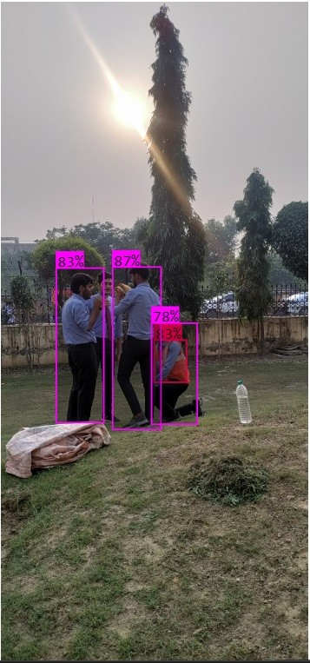

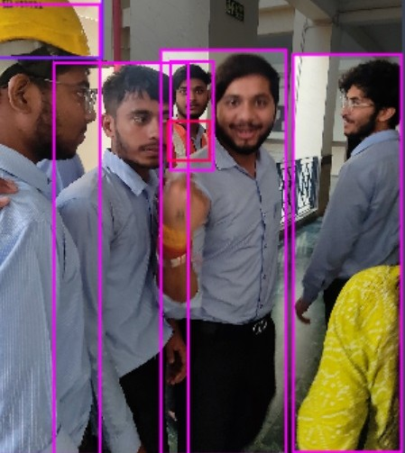

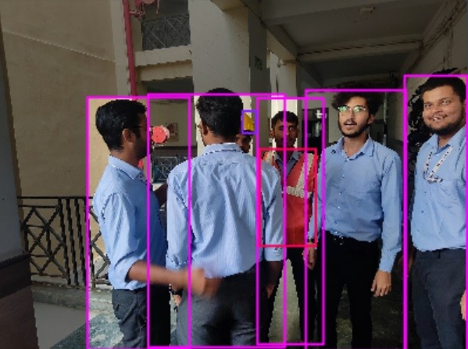

***Good Dataset***

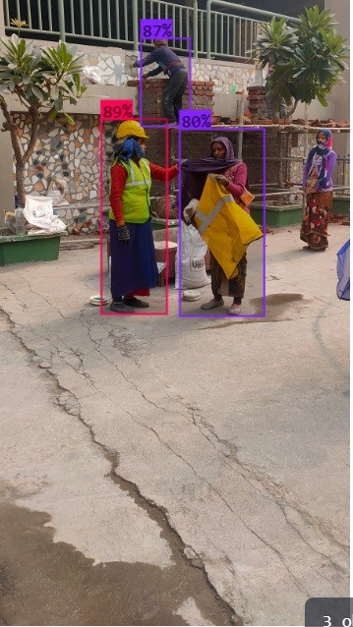

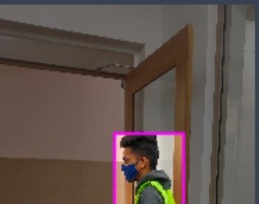

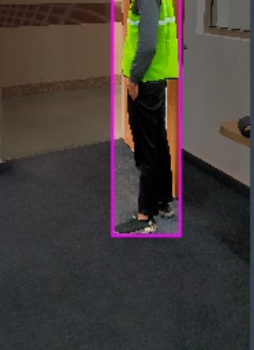

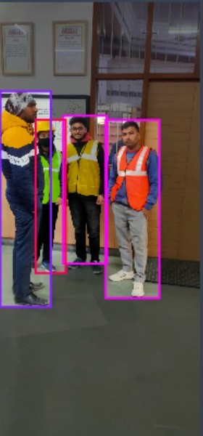

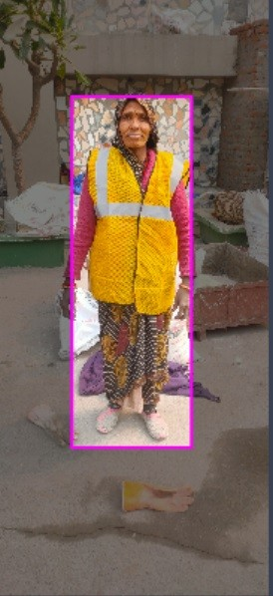

1. **Diverse set of images are to be collected with different colors of jackets and helmets.**
2. **Balance between all the classes - safe, unsafe, without helmet, without jacket, should be maintained**
3. **Random image clicks has to be avoided**